
Press Release 09/2026
Moers in September 2026

Press Release

Small in Size, Big on Flexibility
The new SB-Small roof system concept from Edscha Trailer Systems
Frequent loading and unloading, short distances and numerous stops place particular demands on small transport vehicles. With the SB-Small concept, Edscha Trailer Systems presents a compact sliding bow roof system specifically designed to meet the requirements of distribution transport and the skilled trades. Robust, flexible and easy to operate, the system provides quick access to the load while ensuring that the available cargo volume can be used as efficiently as possible.
As the European market and technology leader for sliding truck roof systems, Edscha Trailer Systems has decades of experience in developing roof systems for a wide range of tarpaulin-covered load carriers. With its innovations, the company established the sliding roof system product segment and has played a major role in shaping its development. This experience also forms the basis for the development of the new SB-Small.
Developed from proven systems
The technical basis of the SB-Small is provided by the proven SB-Profi and TipperRoof systems from Edscha Trailer Systems. However, the concept has been specifically developed further for use on smaller vehicles and adapted to their particular requirements.
The focus is on a robust adaptation to all types of drop sides, a short package length and a complete system solution including the tarpaulin. This makes the SB-Small a practical solution for a wide range of vehicle and body concepts.
Its compact design plays a particularly important role in small transport vehicles. Fixed body components can restrict the use of the cargo space and make work processes more difficult. The SB-Small, by contrast, is designed for maximum flexibility and enables the available cargo volume to be used as fully as possible at all times.
Access from above and from three sides
In daily operation, the load needs to be accessible quickly and easily. The SB-Small therefore allows loading from above as well as from three sides of the vehicle. Users can consequently access the cargo area flexibly and without difficulty.
The divided drop side provides additional flexibility. It allows demand-oriented access to the load and makes work processes easier, particularly when different goods, materials or tools need to be removed or loaded during a route.
As a result, the vehicle remains versatile even when transport tasks change. Especially with smaller vehicle bodies, this flexible access can make an important difference in everyday operation.
Designed for one-person operation
Another key focus in the development of the SB-Small is ease of use. The roof system can be operated quickly by just one person and entirely from ground level.
In this way, Edscha Trailer Systems responds to the requirements of users who have to handle numerous loading and unloading operations during the working day. Straightforward operation can help simplify processes and reduce unnecessary downtime during a route.
At the same time, ground-level operation also plays an important role in terms of health and ergonomics. The system is designed to support everyday work in a practical way and make frequently recurring work processes more comfortable.
Customer requirements at the heart of development
The development of the SB-Small incorporates both the many years of experience of Edscha Trailer Systems and specific user and customer requirements.
The focus is on current requirements such as load safety, ergonomic working conditions, ease of operation and flexible use. Particularly for vehicles that cover many short distances every day, these aspects need to be combined in a practical and effective way.
The SB-Small provides full cargo volume without unnecessarily restricting its use through fixed body components. At the same time, the additional effort required for load securing, for example through the use of nets, can be reduced. This makes work processes easier, particularly in applications where the load changes frequently.
For short distances and frequent stops
The SB-Small is particularly suited to applications in which vehicles stop frequently and are repeatedly loaded or unloaded during a route.
Typical applications include supplier vehicles, small vehicles with drop-side bodies, courier and delivery services, gardening and landscaping, as well as various skilled trades. The combination of compact design, quick access from three sides and one-person operation makes the SB-Small a flexible solution for precisely these types of applications.
A compact solution for today’s requirements
With the SB-Small, Edscha Trailer Systems is expanding its portfolio with a sliding bow roof system specifically designed to meet the needs of small transport vehicles. Proven technology from the SB-Profi and TipperRoof is combined with a compact design and a consistent focus on the requirements of everyday operation. The result is a robust and flexible roof system for users for whom fast loading and unloading, easy accessibility and minimal restrictions on cargo volume are crucial.
Visit us at IAA TRANSPORTATION 2026
Edscha Trailer Systems will present the new SB-Small at IAA TRANSPORTATION from September 15 to 20, 2026, in Hanover. Visitors can find out more about the compact sliding bow solution at Hall 27 | Stand B03 and discover how proven Edscha TS technology can be adapted to the specific requirements of small transport vehicles. We look forward to exchanging ideas and views with you.
About Edscha Trailer Systems
Edscha Trailer Systems is the European market and technology leader for sliding truck roof systems. With its innovations, the company established this product segment and has played a major role in shaping its development. Edscha Trailer Systems develops and manufactures roof systems for a wide range of tarpaulin-covered load carriers, combining many years of experience with practical solutions for the requirements of the transport and logistics industry.
For more information, visit www.EdschaTS.com.

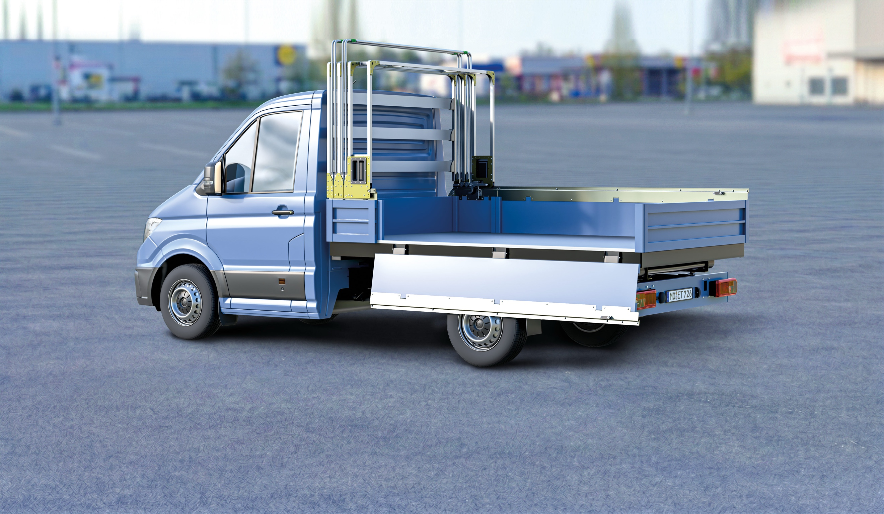 SB-Small
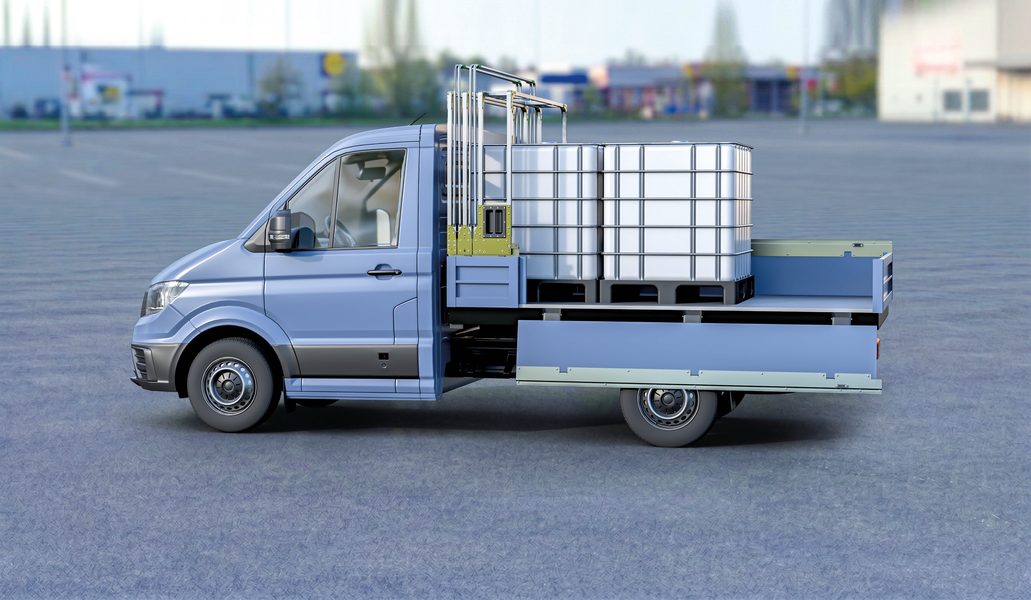 SB-Small, loading
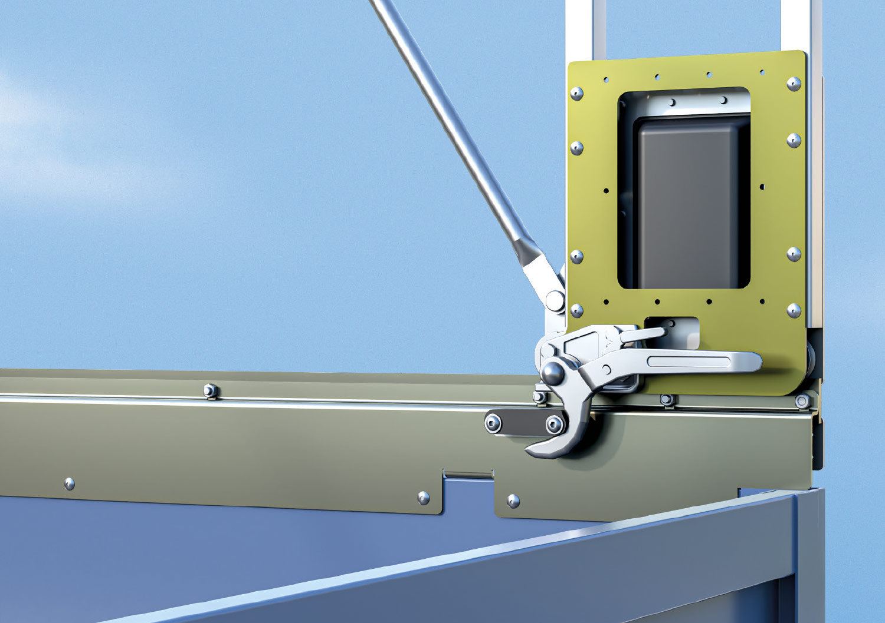 SB-Small, locking inside
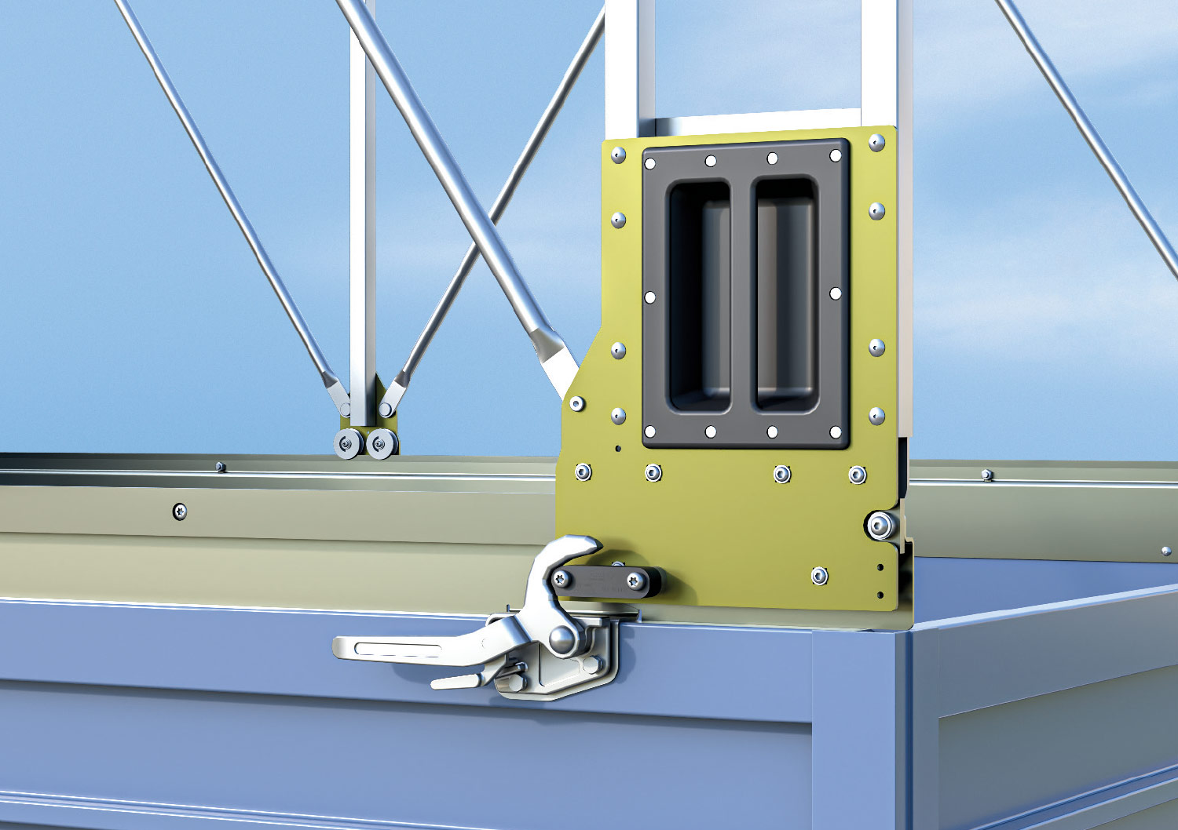 SB-Small, locking outside

Contact at Edscha Trailer Systems:
Mr. Roger Remmel
E-Mail: Marketing@EdschaTS.com
www.EdschaTS.com Member of VBG GROUP

