
Press Release 09/2026
Moers in September 2026

Press Release

Roof Solutions for Road Transport, Industry and More
Edscha Trailer Systems offers a broad portfolio
Different transport tasks require different solutions. Vehicle size, body design, load, loading direction and area of application all determine which roof technology is best suited to the job. Edscha Trailer Systems therefore offers a broad portfolio of sliding tarpaulin roof systems covering a wide range of requirements – from conventional road transport and distribution operations to industrial and special applications.
As the European market and technology leader for sliding truck roof systems, Edscha Trailer Systems has many years of experience in developing roof solutions for tarpaulin-covered load carriers. The portfolio ranges from CurtainSider and full-tarpaulin systems to sliding bow roof systems and solutions for special transport and industrial applications. The range is complemented by systems from the SESAM brand as well as specific product variants for international markets.
CurtainSider – flexibel von oben und der Seite
An important part of the portfolio consists of the CurtainSider systems. They provide wide lateral access to the load and therefore support flexible loading and unloading processes. The CS-Profi is particularly suitable for loading and unloading from above.
With the CS-Hybrid and CS-Profi, Edscha Trailer Systems offers different solutions within this product group. The range is complemented by the QuickCurtain, which focuses on particularly fast and straightforward operation of the side curtain.
The portfolio also includes suitable side curtain accessories. These make it possible to adapt and complement vehicle bodies and systems to meet the different requirements of daily operation.
Full tarpaulin and sliding bow systems for different applications
In the field of full-tarpaulin and sliding bow roof systems, Edscha Trailer Systems offers a variety of solutions. The VP-Standard and VP-Profi are available for conventional full-tarpaulin applications.
The SB-Profi is one of Edscha TS’s proven sliding bow roof systems and also forms the technical basis for further developments within the portfolio. The SB-Profi allows the entire loading area to be used without obstructive body components. It can be loaded from three sides as well as from above.
With the new SB-Small, Edscha Trailer Systems applies this principle specifically to smaller transport vehicles with drop sides. The compact, robust and flexible sliding bow roof system is aimed particularly at distribution transport and the skilled trades. It enables simple one-person operation from ground level as well as flexible loading from above and from both sides.
This makes it possible to cover different vehicle sizes and application profiles within a single product family.
Solutions for special loads and applications
Not every transport task can be handled with a conventional CurtainSider or full-tarpaulin body. For this reason, the Edscha Trailer Systems portfolio also includes systems developed for special requirements.
The TipperRoof expands the range with a roof solution for suitable tipping and bulk-material applications. Here too, practical operation and adaptation to the respective vehicle body are key priorities.
With OpenBox Road & Offroad, Edscha Trailer Systems also offers solutions for applications in which special demands are placed on the vehicle and its operating environment, for example in walking-floor vehicles.
OpenBox Industry transfers the principle of flexible roof technology to industrial applications. This extends the portfolio beyond conventional road transport and creates additional possibilities for a wide range of operational and logistical tasks. OpenBox Industry can be used to create roof structures for events as well as covered outdoor storage areas for materials.
International solutions for different markets
Transport requirements also vary from one market to another. Edscha Trailer Systems therefore takes regional vehicle concepts and operating conditions into account with solutions specifically adapted to them.
For overseas markets, the range includes the VARIO-CS, VARIO-VP and VARIO-OpenBox systems. They expand the international portfolio and make it possible to adapt the basic concepts of Edscha TS roof technology to additional vehicle and market requirements.
In this way, Edscha Trailer Systems combines its many years of experience with the flexibility required for a wide variety of international operating conditions.
SESAM complements the portfolio
In addition to Edscha TS systems, solutions from the SESAM brand are also part of the overall portfolio.
The CS-Slimliner and CS-Flatliner provide further CurtainSider solutions for different vehicle body and application requirements. They complement the product range and give customers and bodybuilders additional options for selecting the system that best matches their particular vehicle concept. The SESAM concept is based on individual components, allowing each bodybuilder to assemble the roof system individually according to specific requirements.
Edscha TS and SESAM therefore offer different technical approaches within a shared solutions portfolio.
One system concept for civilian and special applications
The versatility of the roof systems also opens up applications beyond conventional civilian transport logistics. The topic of dual use is becoming increasingly important, particularly in the field of commercial vehicle solutions, where robust, durable and flexible systems are required for a wide range of tasks.
Sliding tarpaulin roof systems, side curtain solutions and modular assemblies from Edscha Trailer Systems are primarily developed for civilian transport and logistics applications. However, depending on the system, configuration and specific intended use, characteristics such as robustness, durability, flexibility and practical operation can also make them suitable for other logistical and military applications.
The same basic principle of the portfolio applies here: no single system has to fulfil every task. What matters is selecting the right technical solution for the respective application.
Different systems for different requirements
From small distribution vehicles and conventional commercial vehicle bodies to specialised transport and industrial applications, Edscha Trailer Systems covers a broad spectrum with its various sliding tarpaulin roof systems.
Each system has its own advantages and specific areas of application. Key factors include the type of vehicle and body, the type of load, the loading situation and the requirements of daily operation.
The result is a portfolio that allows customers and bodybuilders not only to choose between different products, but also to select the roof solution that is specifically suited to their individual transport task.
Visit us at IAA TRANSPORTATION 2026
Edscha Trailer Systems will present the full range of its roof solutions at IAA TRANSPORTATION from September 15 to 20, 2026, in Hanover. Visit us in Hall 27 | Stand B03 and discover the different systems from Edscha TS and SESAM. Our experts will be available on site to answer questions about roof types, vehicle bodies, loads and individual application requirements.
About Edscha Trailer Systems
Edscha Trailer Systems is the European market and technology leader for sliding truck roof systems. With its innovations, the company established this product segment and has played a major role in shaping its development. Edscha Trailer Systems develops and manufactures roof systems for a wide range of tarpaulin-covered load carriers, combining many years of experience with practical solutions for the requirements of the transport and logistics industry.
For more information, visit www.EdschaTS.com.

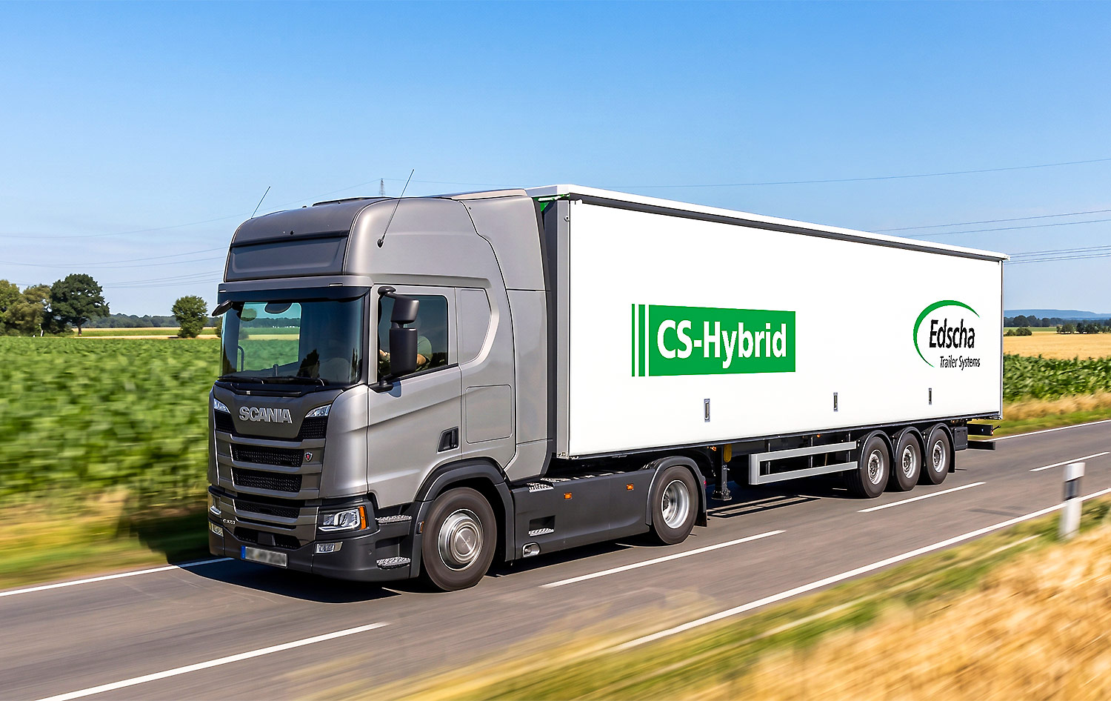 Curtain-Sider Roof CS-Hybrid With Side Curtain System QuickCurtain
 Full Tarpaulin Roof VP-Profi
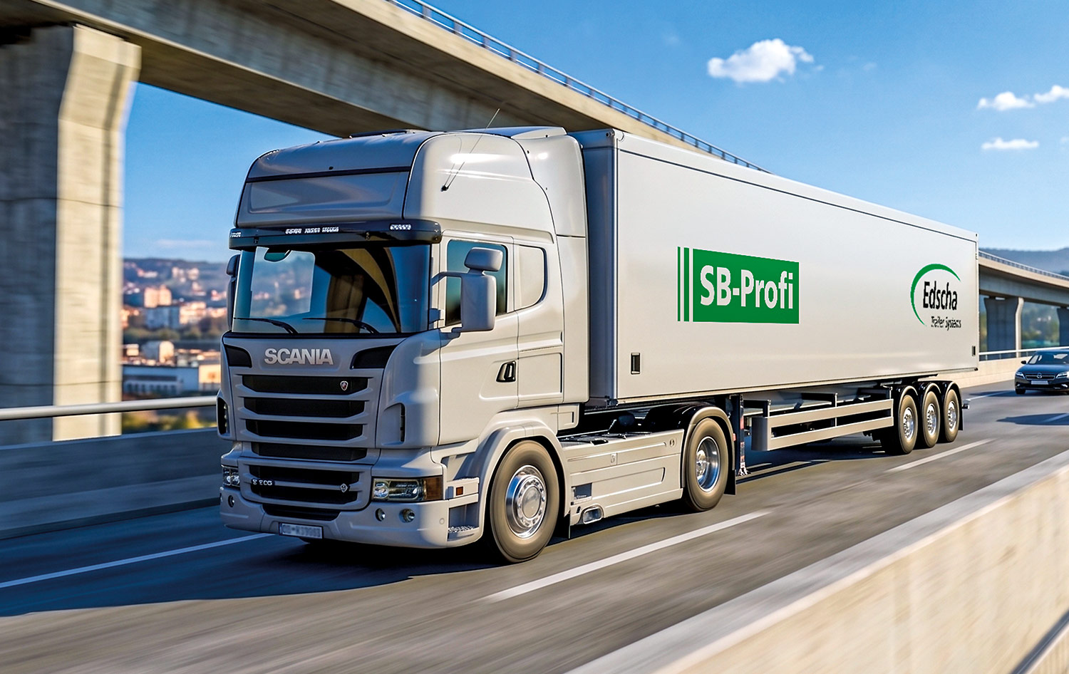 Sliding Bow Roof SB-Profi
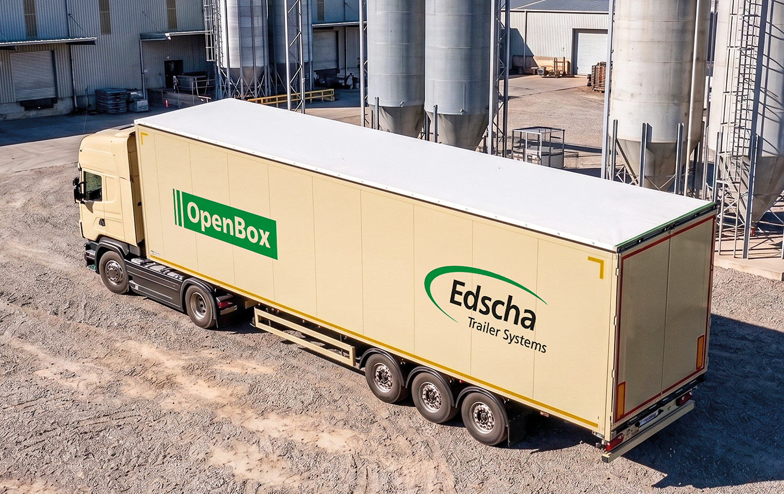 Solid Wall Roof OpenBox Road & Offroad
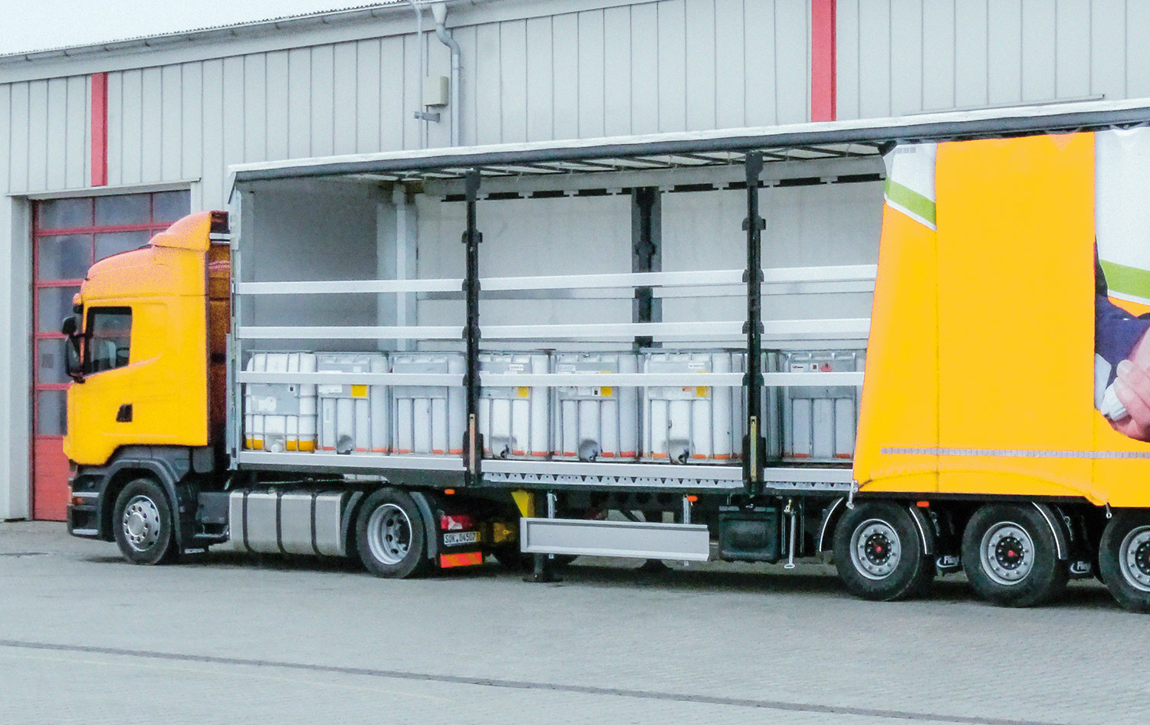 Curtain-Sider Roof CS-Slimliner by SESAM

Contact at Edscha Trailer Systems:
Mr. Roger Remmel
E-Mail: Marketing@EdschaTS.com
www.EdschaTS.com Member of VBG GROUP

