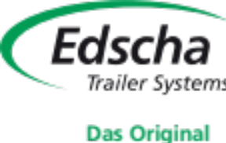
Press Release 09/2026
Moers in September 2026

Press Release

Sliding Curtain Roof Systems Up Close
Edscha TS and SESAM showcase solutions for a wide range of body types and applications at IAA TRANSPORTATION 2026
Different loads, vehicle types and areas of application place different demands on a roof system. At IAA TRANSPORTATION 2026 in Hanover, Edscha Trailer Systems will therefore present a broad selection of its sliding curtain roof systems, allowing visitors to experience the specific advantages of each solution directly at the exhibition stand. Together with the SESAM brand, Edscha TS will showcase solutions for a wide variety of vehicle bodies and transport tasks – from proven systems for conventional transport applications to specialized solutions for smaller vehicles and industrial applications.
Whether loading from above, flexible access from the side, specific vehicle body requirements or special operating conditions: each roof system has its own strengths and is optimized for specific tasks.
Compare different sliding curtain roof systems directly
At the exhibition stand, trade visitors can take a close look at, experience and compare numerous Edscha TS and SESAM systems. On display will be the CS-Hybrid, SB-Profi, VARIO-CS/OpenBox Combi, TipperRoof, the new SB-Small, VP-Profi, OpenBox Industry and the SESAM CS-Slimliner.
The different exhibits demonstrate just how varied the requirements within the transport sector can be. While particularly flexible side access may be crucial in one application, other operations may focus on loading from above, specific body designs or special requirements arising from daily use.
Instead of offering one universal solution for every application, Edscha Trailer Systems relies on a range of roof concepts that can be specifically matched to different requirements.
The vehicle body is a key factor
Choosing the right roof system does not depend solely on the cargo being transported. The respective vehicle and body type also play a decisive role.
Edscha Trailer Systems develops solutions that can be adapted to different body types and vehicle concepts. This allows the specific advantages of a system to be combined with the technical characteristics and requirements of the vehicle – for both individual vehicle bodies and/or series production.
Bodybuilders and vehicle manufacturers can find out directly at the trade fair which systems are suitable for their projects and what customization options are available. Technical questions can also be discussed directly with the Edscha TS experts on site.
Flexible loading from different directions
How quickly and flexibly a vehicle can be loaded and unloaded has a major impact on its everyday operation. One of the key advantages of many Edscha Trailer Systems roof solutions is therefore their excellent accessibility to the cargo.
Depending on the system and body configuration, the vehicle can be loaded from above as well as from the sides. This makes it possible to accommodate different loading situations and use vehicles more flexibly.
Whether side loading and unloading by forklift, access to individual loading areas or loading from above, visitors to the exhibition stand can see which roof solution best meets their specific requirements. In addition, side curtain systems also play an important role in enabling fast loading and unloading.
Discuss your requirements directly on site
IAA TRANSPORTATION not only provides an opportunity to examine the systems up close. Personal discussions with Edscha Trailer Systems specialists are also a key part of the company’s presence at the trade fair.
Visitors can discuss specific questions relating to cargo, loading, vehicle bodies and technical applications directly on site. This applies both to existing applications and to new vehicle body projects.
Based on the individual requirements, the experts can work together with interested visitors to determine which system is suitable, what technical options are available and how a solution can be adapted to a specific vehicle body.
For professionals throughout the entire transport chain
The Edscha Trailer Systems stand is aimed at a wide range of visitors from the transport and commercial vehicle industry. Vehicle manufacturers and bodybuilders, transport companies, fleet operators, dealers, drivers and customers can obtain targeted information about the systems relevant to their needs.
Bodybuilders gain insight into technical solutions and customization options. Users can discuss questions arising from their daily operations directly with the experts. Transport companies and fleet managers can compare different concepts and assess which solution best matches their transport tasks and vehicles.
This makes the exhibition stand a meeting point for different perspectives – from technical integration to practical day-to-day operation.
Systems to experience and understand
Technical characteristics are best assessed when they can be experienced directly. This is precisely why the exhibits themselves take center stage at IAA TRANSPORTATION.
Visitors can examine the various systems up close and gain a clear understanding of their design, functionality and potential applications. The combination of exhibited solutions and individual consultation helps visitors better understand the differences between the various roof system types and assess the respective advantages for their own applications.
In this way, Edscha TS and SESAM present not only individual products, but a broad portfolio of solutions for a wide variety of requirements in everyday transport operations.

From individual requirements to the right roof solution
Ultimately, the right solution depends on the specific application. Vehicle type, body design, type of cargo and loading and unloading processes all need to be considered together.
With its broad portfolio of different roof systems and technical consultation available on site, Edscha Trailer Systems supports its customers in finding the right solution for each application. IAA TRANSPORTATION provides the ideal opportunity to compare systems directly, clarify questions and discuss individual requirements with the experts.
Visit us at IAA TRANSPORTATION 2026
Experience the roof systems from Edscha TS and SESAM first-hand at IAA TRANSPORTATION in Hanover from September 15 to 20, 2026. Visit Edscha Trailer Systems in Hall 27 | Stand B03, discover the different exhibits and talk to our experts about your individual requirements for vehicle bodies, loading and transport.
About Edscha Trailer Systems
Edscha Trailer Systems is the European market and technology leader for sliding truck roof systems. With its innovations, the company established this product segment and has played a major role in shaping its development. Edscha Trailer Systems develops and manufactures roof systems for a wide range of tarpaulin-covered load carriers, combining many years of experience with practical solutions for the requirements of the transport and logistics industry.
For more information, visit www.EdschaTS.com.

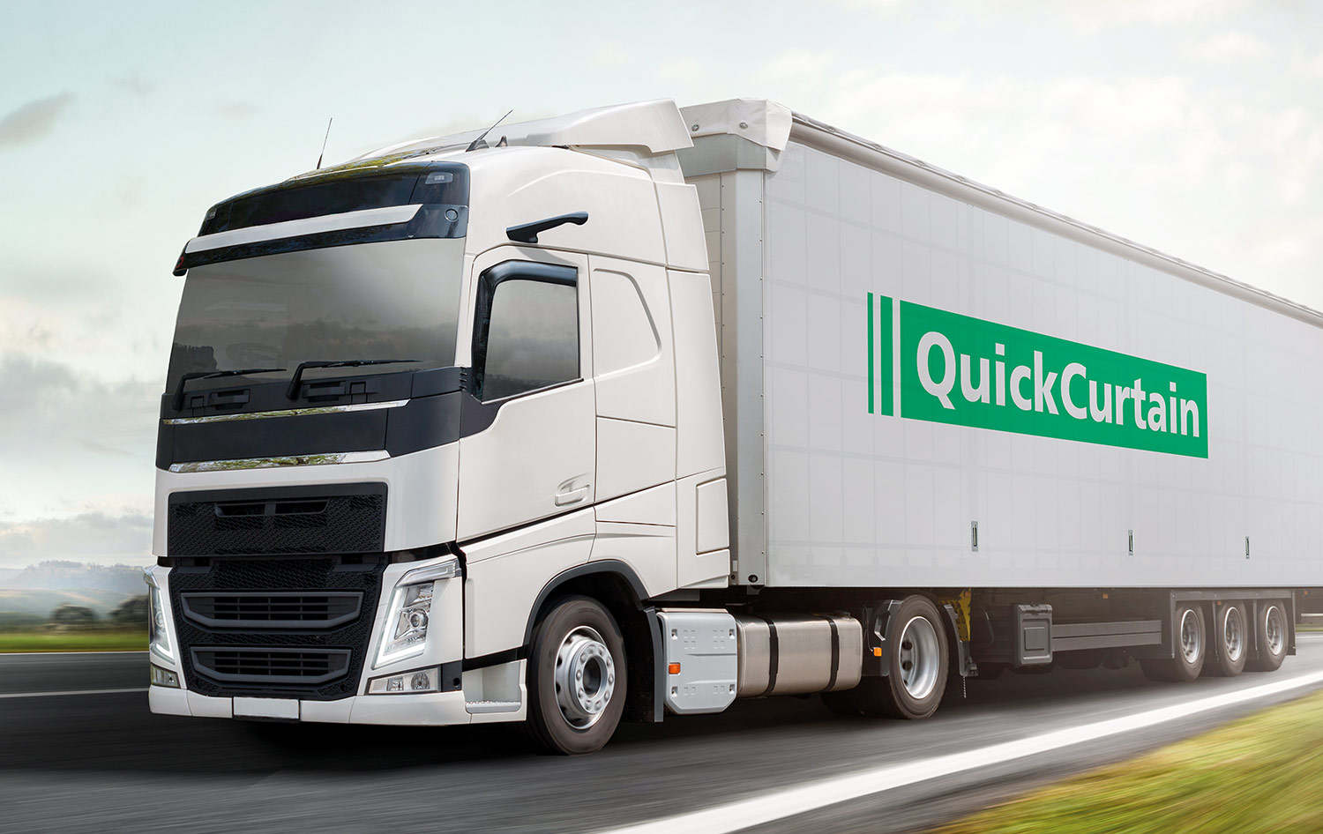 CS-Hybrid with QuickCurtain
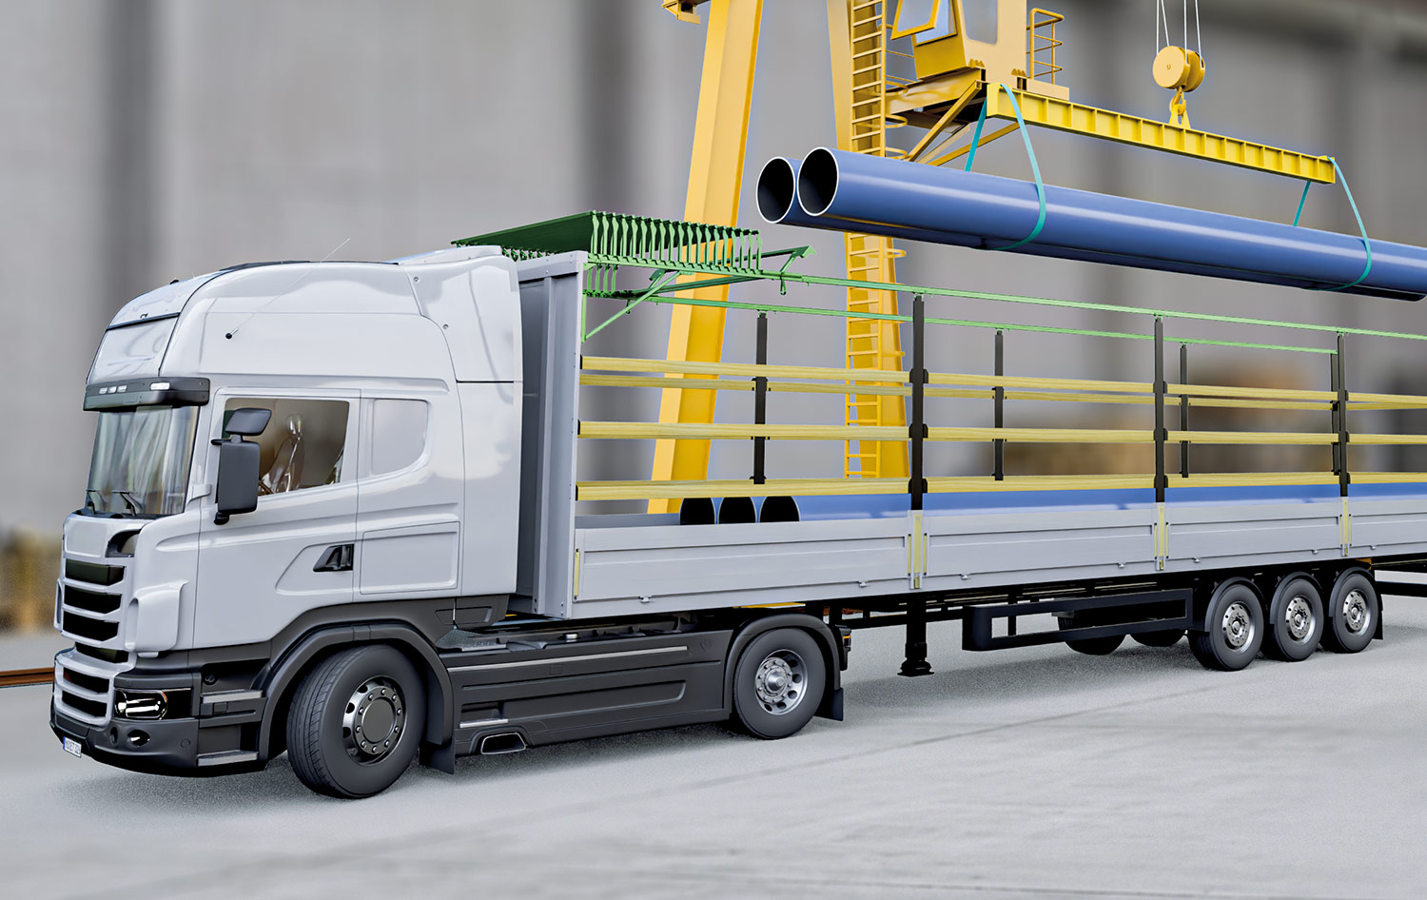 VP-Profi
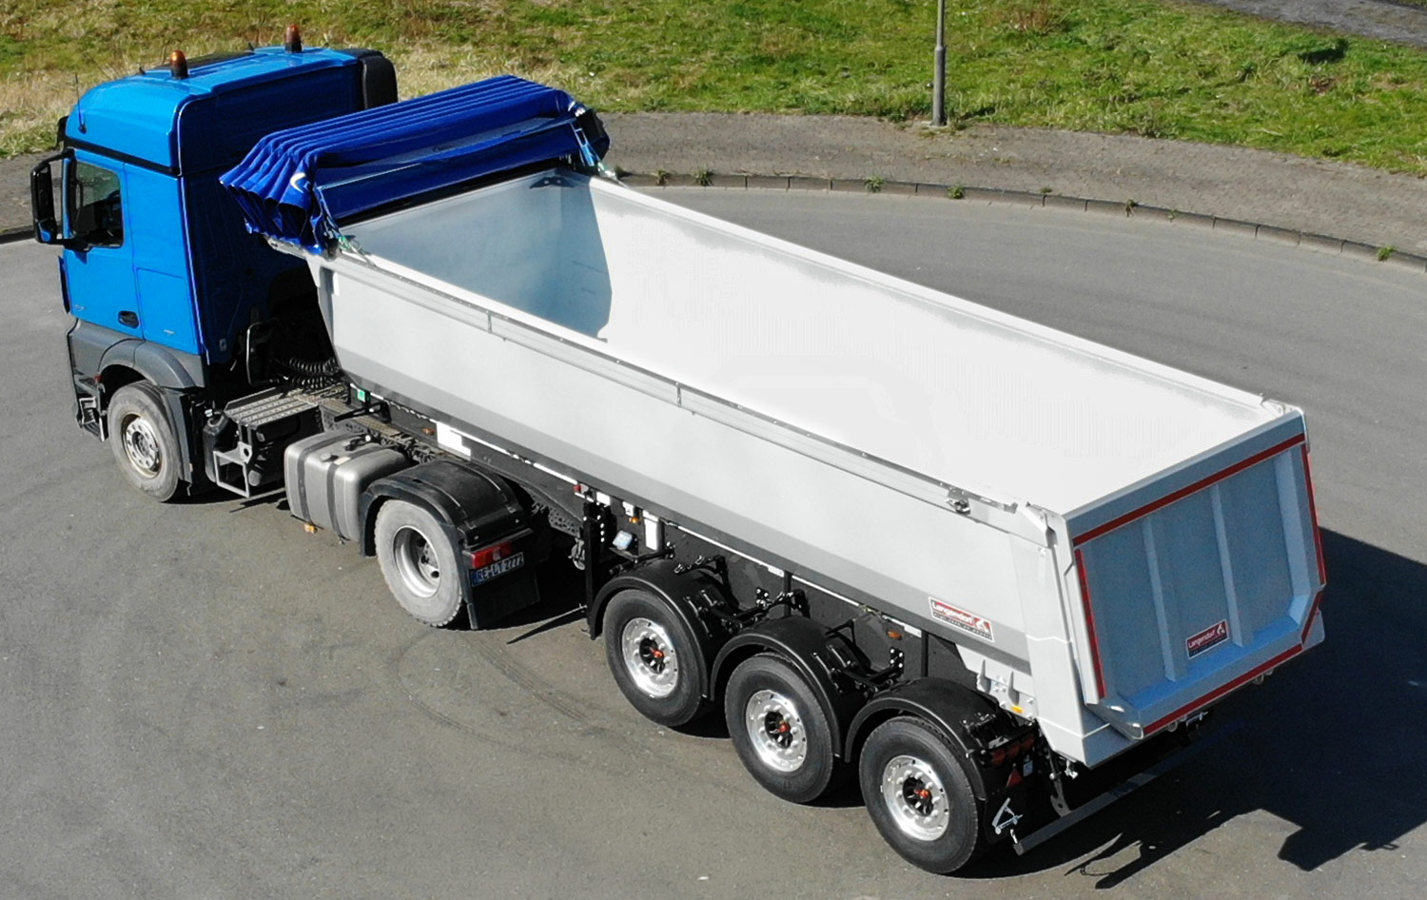 TipperRoof
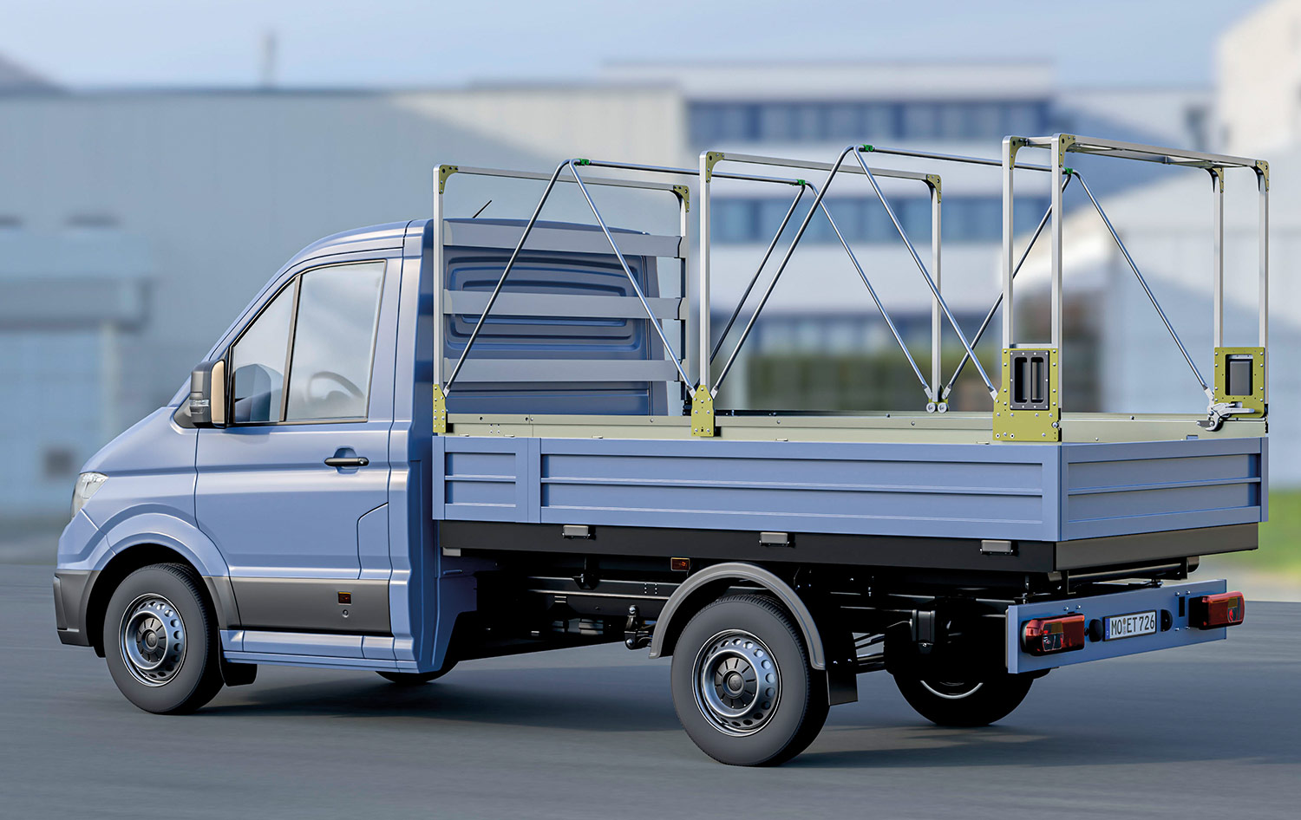 SB-Small
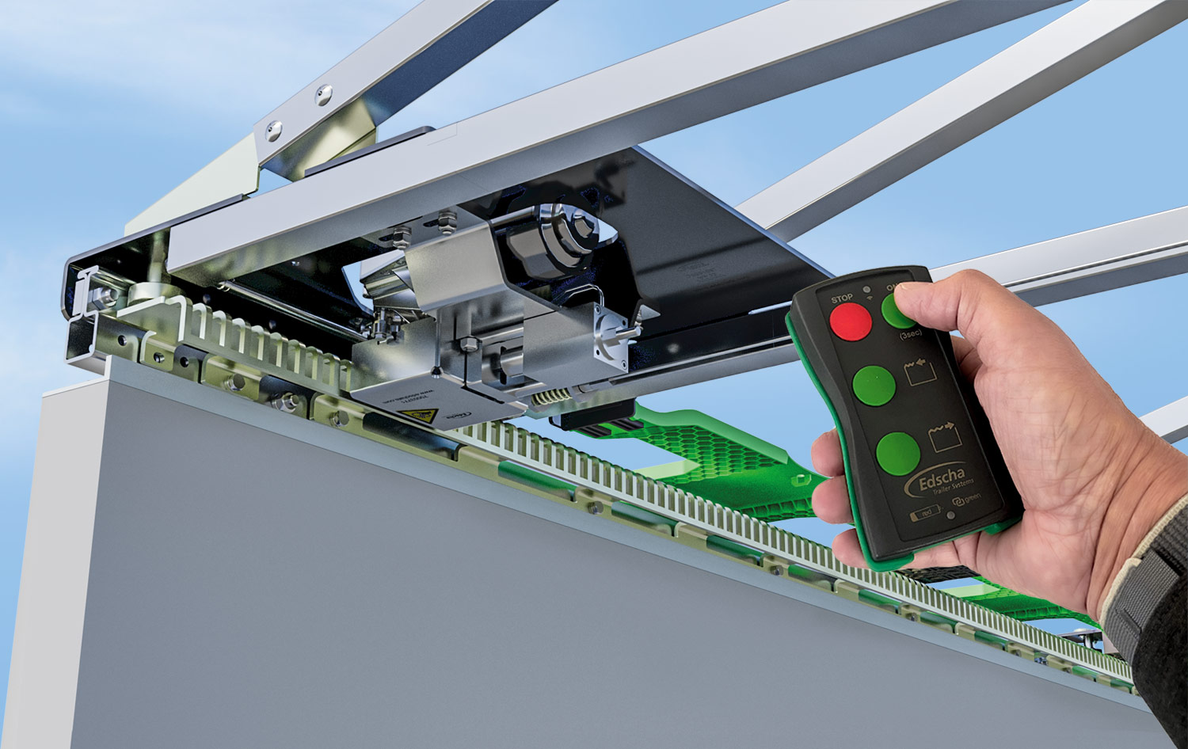 OpenBox Industry

Contact at Edscha Trailer Systems:
Mr. Roger Remmel
E-Mail: Marketing@EdschaTS.com
www.EdschaTS.com Member of VBG GROUP

