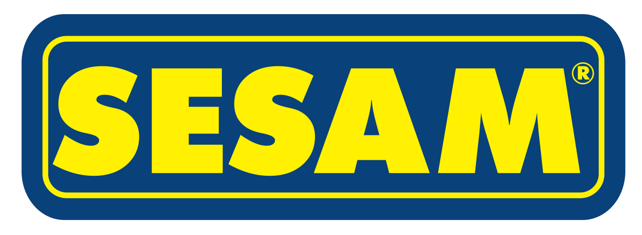
Press Release 09/2014
Moers in September 2014

Not duty-free but TIR compliant

SESAM introduces new CS-Slimliner components and a system
for TIR compliant sealing for customs transit

Edscha Trailer Systems, Europe’s market and technology leader for sliding roofs for trucks, launches newly developed CS-Slimliner components onto the market under its second brand, SESAM, now also with TIR compliant roof tarpaulin fastening. The new product range offers a smart kit system with cover solutions for panel curtain superstructures which satisfy all applicable standards.

The new SESAM TIR set comprises special side tarpaulin roller securing, the red TIR steel rope, customs-compliant secure Maxlock riveting of the cover roller and end carriages and associated tensioning and installation accessories. It is therefore fully compliant with all customs requirements for the international transit of goods. Two sets with special accessories are provided to ensure that the Curtain Sider remains fully sealed: One set for roof tarpaulin fastening and one set with special sliding tarpaulin rollers to secure the side curtain.
In the course of the TIR set presentation, SESAM will also introduce a condensed and revised range of the CS-Slimliner smart component kit system. Sliding roofs configured based on this can offer solid basic functionality, even under unfavourable day to day conditions. The simplicity of the SESAM system offers manufacturers and carriers many advantages. The patented slide-in system with the SESAM folding plates and the use of only a few standardised components renders installation quick and easy.
The sliding roof components of the SESAM product range for basic requirements are remarkable in their intelligent use of plastics and steel in functional tarpaulin roof systems. Slimliner sliding covers offer solid kinematics and ease of handling. The roof is optimised for standard demands and boasts durable plastic joints and coated steel roller carriages. The kit system ensures that the Curtain Sider Slimliner roof finds flexible application on a variety of vehicles.
The now introduced optimised version boasts new roller carriage geometry with generous profile clearances, robust steel end carriages, embossed and calibrated roof bows with a new optimised roof strap concept and a panel curtain system offering far more than the cost-effective investment may lead you to expect.

More information: Please visit hall 26 stand A26

www.EdschaTS.com member of VBG GROUP

